**WEBSITE OF DR. CHANGKITCHEN**

**FOR BETTER AND EASIER ORDER**

**By : Vincentius Susanto, Putri Aurelia S, Julio Rivaldo G**

Universitas Bina Nusantara @Malang

**ABSTRACT**

Diet catering is intended for those who have a goal to live healthier and lose weight. This is done by paying attention to the amount of nutrition or nutrition. The writing of this report aims to develop a web-based diet catering business so that the transaction process between the two parties is easier and faster. The web development process consists of several stages: Analysis, Design, Implementation and Testing Deployment, Maintenance. This diet catering web development uses Brackets as the IDE and by implementing the Waterfall software development model. This website is a way to promote our diet catering products and also to simplify and streamline the transaction path between sellers and buyers because all activities and goals of users will be included in the data. Users who can access this website will be divided into 3 users as non-members, members, and admin. The Non-members can view products and testimonials on our homepage and if non-members want to make a purchase they can order by using social media such as Instagram, Whatsapp, and Line. The Members can make orders and transactions through website. Admin will see the existing transaction process and perform maintenance on the web.

***Keywords---Diet Catering; Searching fot Diet Catering; Waterfall Model; UML***

1. **Introduction**

In this modern era, the internet has been widely used or even has become the needs of the majority of people in Indonesia. The internet is one of the tools that can help make it easier for people to find or do something. The growth in the number of internet users in Indonesia continues to grow over time until it reaches around 17 percent. Therefore, in this sophisticated era, there are also many people who use the internet as a means to facilitate them in running their business or start-up in various fields, including the culinary field. This can be seen through the many websites or applications for ordering food or daily catering that is available.

The existence of websites about culinary businesses, especially catering diets, certainly brings many benefits to the business owner. That is because by using the website, people will be able to more easily access and find out about the catering business. The public can also easily get complete information about the catering business through the website that has been provided. The transaction process will also be easier because in general, practical payment methods have been provided through the website. In addition, the promotion of this business can also be done online (through the website and social media) so that business owners can also save more costs used to print brochures and the profits obtained are also getting bigger.

Seeing the number of enthusiasts catering diets make many related businesses that arise. The number of online diet catering businesses has caused intense competition in the scope of this business. However, sometimes there are also catering diets that do not pay attention to customer nutritional needs and not necessarily the products produced can be in accordance with the customer's dietary desires. In addition, there are also many diet foods that have a bland or unpleasant taste so that people who consume them become lazy to go on a diet.

If these problems are not immediately resolved, then the diet catering business will not run smoothly. Customers can also become lazy to go on a diet. This can be because the price of food paid does not match the taste and nutritional content needed. The price of diet foods that are not cheap and is accompanied by a sense of torture because they have to eat unpleasant diet food makes customers lazy to order food at the venue.

Therefore, the making of this diet catering website aims to help overcome the problems experienced by these customers. In this website, there are various complete information about the diets and nutritional needs of various types of diets. This diet catering also provides food according to what the customer wants and with good taste like he is not on a diet. The way this website works is by providing information about the diet and then information about the food packages that have been provided. Under this option, customers can submit special requests regarding diet foods that will be ordered. In addition, on this website special promotions are also given which will be updated every month. After selecting a package, the customer only needs to proceed to payment and proof of payment confirmation will be sent to the customer.

1. **Literature Overview**
2. ***Website***

Website is a collection of web pages that have close links between one page and another and each of them can be accessed through a homepage using a browser and internet network. In general, a web page contained on a website contains a collection of information that is presented in various forms, such as text, images, animation, audio, video, or a combination of these forms. Typically, websites are created with a variety of purposes, both for personal interests or the interests of an organization or company (business). The website itself consists of two types, namely static websites and dynamic websites. Static website means the content or information contained in the website is permanent and only comes from the website owner. The example of a static website is a website that is owned by an organization or company whose contents only come from that group or company. While dynamic websites are websites whose contents or information contained in them are impermanent or always subject to change. Changed of the information content of dynamic websites can be made by anyone, both by the website owner and the user of the website itself. Examples of dynamic websites are social media websites, such as Twitter, Facebook and so on. In making a website, there are elements that are very closely related so that the website can be accessed easily, namely domain, hosting, and content. Domain can be said as a "brand" or a distinctive marker of the website. Hosting can be used to store all data or information contained on the website. These data can be in the form of text, scripts, images, audio, and so on. While the content is the content or purpose of making the website. The content contained on the website is usually in the form of text, images or videos in accordance with the purpose of the website.

1. ***PHP***

PHP or Hypertext Preprocessor is a programming language that is usually inserted in HTML and in its use can be combined with a variety of other programming languages. The use of PHP in website development in general is because PHP has interesting features and is easy to use. PHP uses a server-side programming system, which is a programming language that will later be run by the server. As for the advantages of this system, the simple programming language makes it easy to use, understand and learn. PHP is a popular language in website programming because of its advantages which are open source so that developers don't have to wait until the latest update is released. PHP also causes the appearance of the website can be developed or arranged to be more dynamic than just using HTML that is still fixed or static so that it is considered normal because the appearance has not been able to adjust to the condition of the user's device. This means that websites created using PHP can better adjust their appearance to the devices owned by the user and the database input and output process can be done. By using PHP, web-based applications can be developed in a complex, easier and faster way.

1. ***Framework***

Framework is one thing that is very familiar because it is used by programmers in developing applications and the web. Framework is a program framework that can help a developer in developing code consistently. The framework is used because it can simplify programming because there are functions or programming components that are ready and can be used at any time so as to shorten and facilitate developing. In addition, by using a framework, a developer can also reduce the number of possible bugs that will occur on a system or website that is created and in its development becomes more secure, fast, practical, structured and structured. By using a framework, a developer only needs to arrange the components he needs in programming that has become so that he does not need to write program code repeatedly. The framework itself is also divided into 2, namely desktop frameworks and web frameworks. On a desktop framework it can be used like Net. Framework, JavaFx, Electron and on web frameworks like Yii, Code Igniter, Bootstrap.

1. ***Waterfall***

The Waterfall Model is a linear and sequential software development using a method or model that can also be used by others in developing software systems. Waterfall is also a method that can be done in making updates on the running system. This waterfall consists of five to seven phases, each phase defined by different tasks and objectives. This Waterfall Model consists of Requirement Gathering and Analysis, System Design, Implementation, Integration and Testing, Verification, and Operation and Maintenance. The benefits of using the waterfall model, namely practicality in engineering that can make the quality of the software is maintained. The waterfall model is also a complete type of model so that it makes it easier to maintain.

1. ***Unified Modelling Language (UML)***

Unified Modeling Language (UML) is a modeling design program with object-oriented concepts. UML can be said as a substitute for object-oriented analysis and design methods. In addition, UML is also a combination of the Booch, Rumbaugh (OMT) and Jacobson methods whose scope is wider than OOAD. Making UML aims to create a modeling language that is more easily understood so that it can be used by humans and machines. One part of UML is a diagram. By using diagrams, users will be able to more easily understand what can be done by the website. The UML diagram form that will be discussed, namely Use case diagrams, Activity diagrams, and Class diagrams.

1. Use Case Diagram

Use case diagram is a graphical description of several actors, use cases, and interactions that occur between actors and the system used. In other words, the use case diagram does not explain in detail the use case, but only provides a brief description of the relationship between actors, systems and use cases in achieving a particular goal. Use case diagrams are made aimed at making it easier for developers to communicate the usability of the system or website created.

1. Activity Diagram

Activity diagram is a diagram that represents the flow or flow of activities that will take place in the program created. Activity diagram contains about how the activity process begins, the possibility of decisions that occur during program execution, and how the system will stop. Making activity diagrams aims to explain the sequence of activities that occur in high and low level business processes so that the whole process can be more easily understood.

1. Class Diagram

Class diagram is a visual form of the system structure contained in a program and the flow of the database contained in a system or program. Class diagrams are made to explain a data model for program information, both simple and complex and to increase understanding of the general picture of a program. That is because the class diagram is able to provide an explanation of the implementation-independent of the type of program used which will then be passed through various components contained therein.

1. **Program Implementation**
2. **Research Phase**

In this study, the writer divides the stages of the study into three parts, namely planning, implementing, and writing. The following is an explanation at the research stage:

1. Plan

Before making a project, the developer surveys the existing website. After conducting a survey the developer uses the platform to create design interfaces. The developer determines the function and design that fit the project theme.

1. Implementation

After going through the planning stages and getting the design picture, the developer does and maximizes the design that has been planned in accordance with the desired results. Implementation in making business websites using the Waterfall model.

1. Writing

The developer makes a report regarding the results of making the project based on the results of the experiment and in accordance with the software development model.

1. **Requirement Analysis**

At this stage, the developer describes and analyzes the needs and behavior of the user towards the product. In this phase, the developer conducts research on potential users as to what they want when opening and entering the website. Potential users are referred to as subjects who want to diet, do a healthy life and for those who are doing body building. Also at this stage will be analyzed how this system will meet user needs when using this website to place an order. To access orders via the website the user needs to log in first if not, login can order via social media. Orders will be processed when the transaction has been sent to the admin via the website.

The website is expected to do the following:

* Customers can order food through the website by creating an account first.
* Customers can see testimonials and order schedules.
* Customers can see the shopping history in the basket.
* Customers can determine the number of orders desired.
* Customers can see payment confirmations and get invoices.
* Customers can make payments via transfer and e-money.

1. **Design System**

At this stage, the developer describes the needs and behaviors that the system can perform in the form of UML. UML diagrams that are made are Use Case Diagrams, Class Diagrams, and Activity Diagrams and display on the website or called the user interface.

1. Use Case Diagram

The developer visualizes what actors can do with the system. Each actor has a different role in the system developed. In this web system is divided into 2 actors, namely Customer and Admin or Staff. What customers can do on this system are:

* Customers will enter the website to place an order.
* Customers can view information and testimonials on the web homepage without logging in.
* Customers can see monthly promo updates.
* Customers can register an account by filling out the form provided.
* Customers can log in if they already have an account.
* Customers can choose and see the desired package.
* Customers can order food via the website if it is logged in.
* Customers make payment after payment confirmation.
* Customers can log out from the account.

In addition, there are things that can be done by the admin or staff, namely:

* Admin can update the promos that are available every month.
* Admin can check and confirm payments made by the customer.
* Admin can send proof that the transaction carried out by the customer is successful.

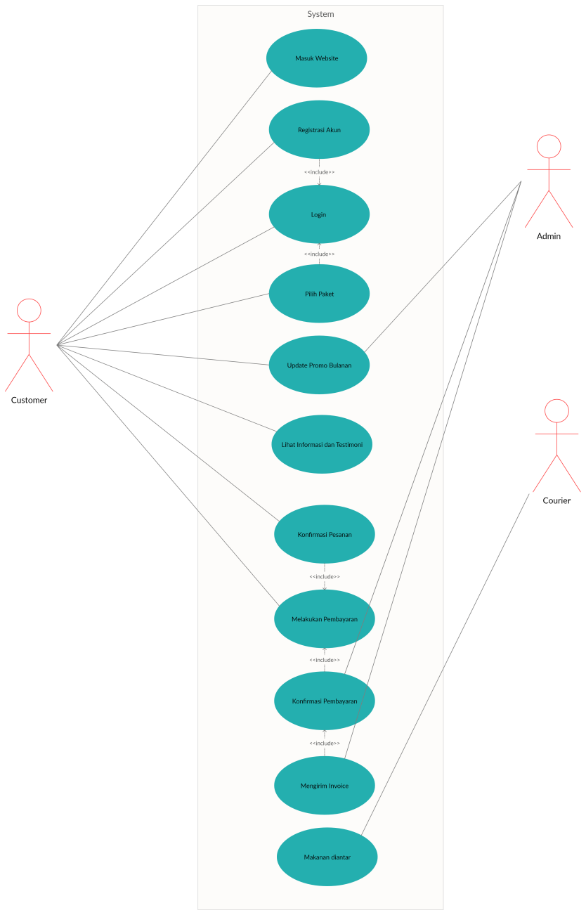

*Pict 3.1 Use Case Diagram*

1. Class Diagram

The UML Class Diagram on this website consists of seven classes as shown in Figure 3.2 below. Each class has different responsibilities and functions commonly referred to as attributes and operations. User class is used as login or login to the website, divided into admin and customer. Admin and customer classes are the user's biodata. Class Order to store data about an order. Payment class for storing and sending proof of payment. Product class is used to store biodata of available goods and stock availability. Shopping Cart class is used to store food data in the long run.

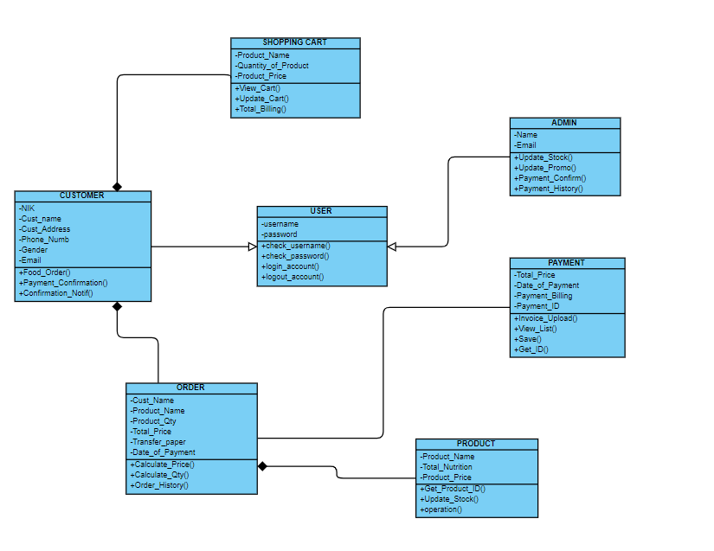

*Pict 3.2 Class Diagram*

1. Activity Diagram

To start using this website, the user must first enter the website address. Users can be divided into two, namely customer and admin. For Customers broken down again into 2 registered customers and unregistered customers, to register themselves to place an order via the website can first register an account for those who do not register can place an order via social media. For admins already registered from the beginning of web development. To do it via the web, registered customers can login. If the username or password entered is incorrect or not registered, you can re-login again. After logging in or not the customer can see monthly diet and promo information on the website homepage. Next to order can choose a package which is then confirmed by the user whether to proceed for payment or not. Then after confirming the order, the total payment will be calculated by the system and then bills the customer to continue payment. After making a payment the system will check the payment which will then be confirmed to the admin if the transaction is successful. After the transaction is successful the admin will give an Invoice to the customer. After that the customer waits for the order to be delivered according to the address given.

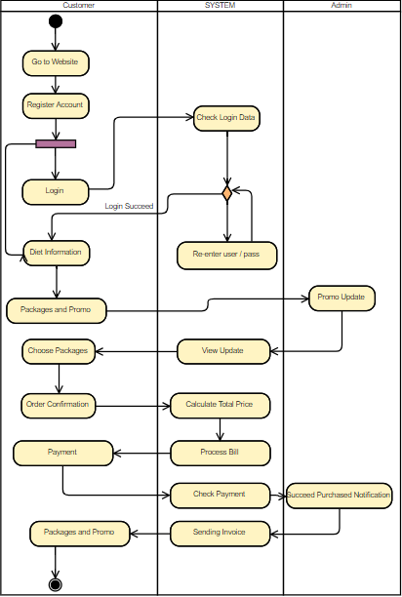

*Pict 3.3 Activity Diagram*

1. **Deployment and Testing Deployment**
2. **Testing Deployment**

PRELOADER

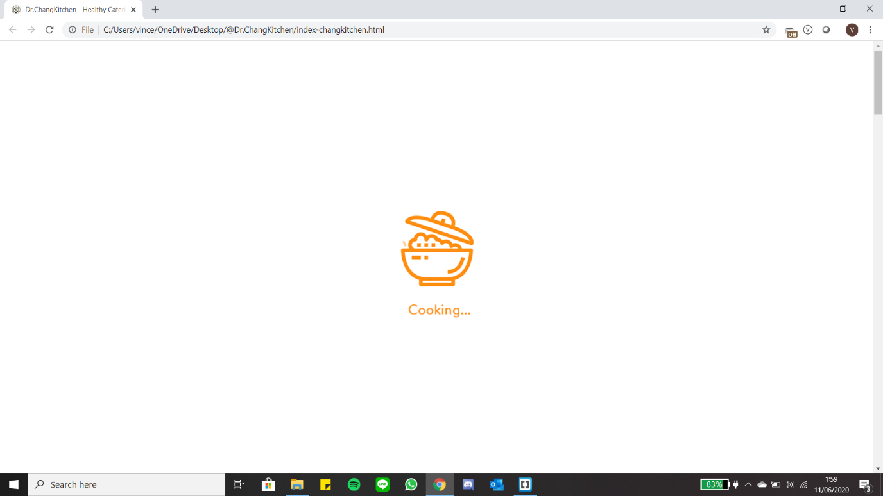

HOME PAGE

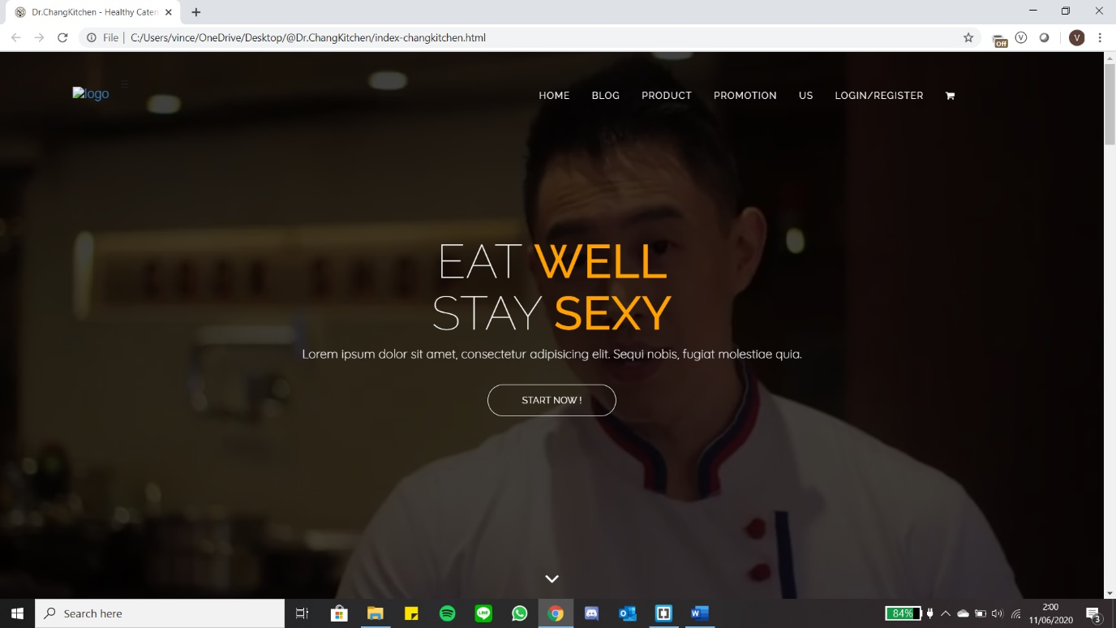

MAIN COURSE

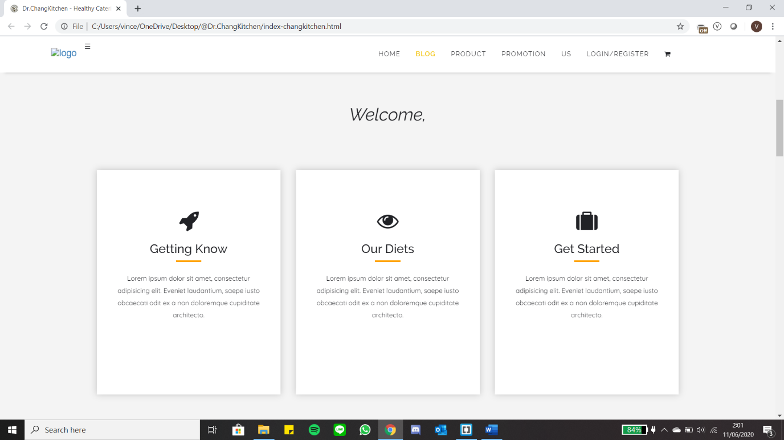

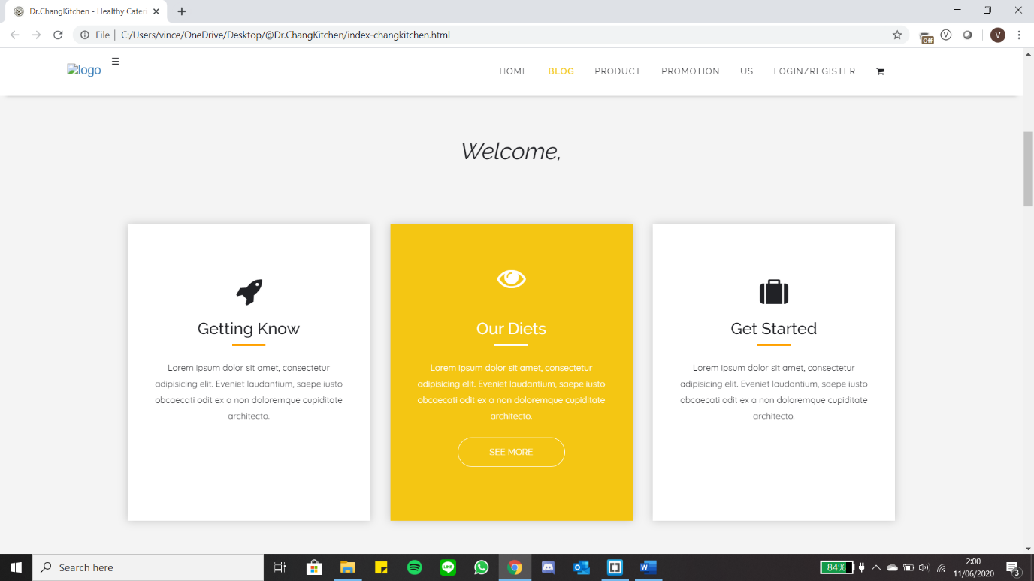

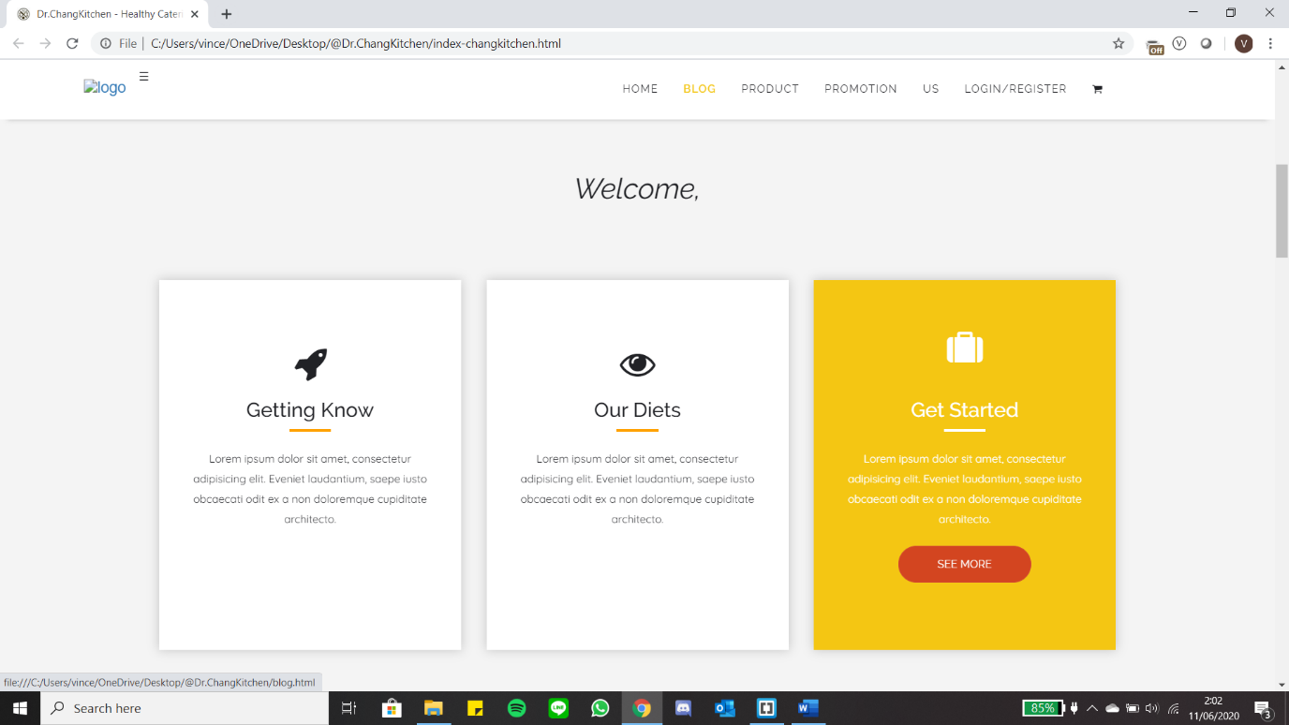

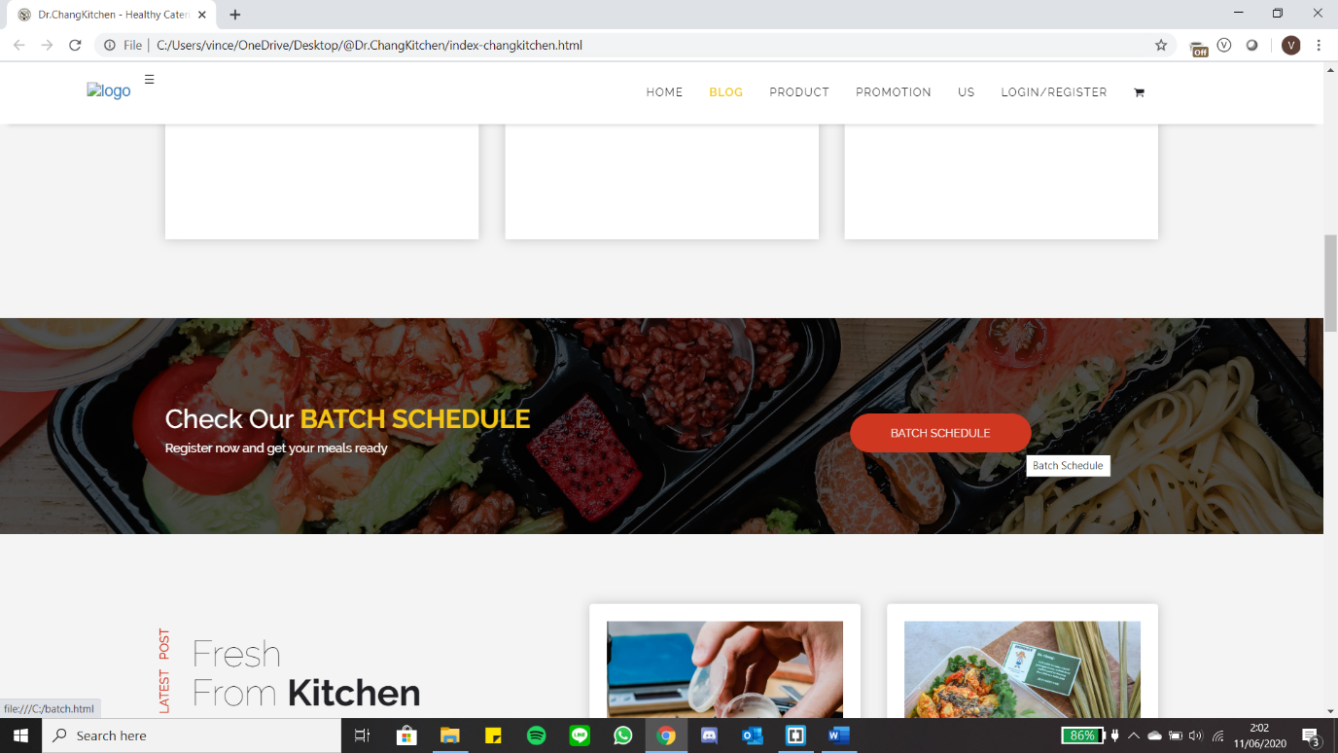

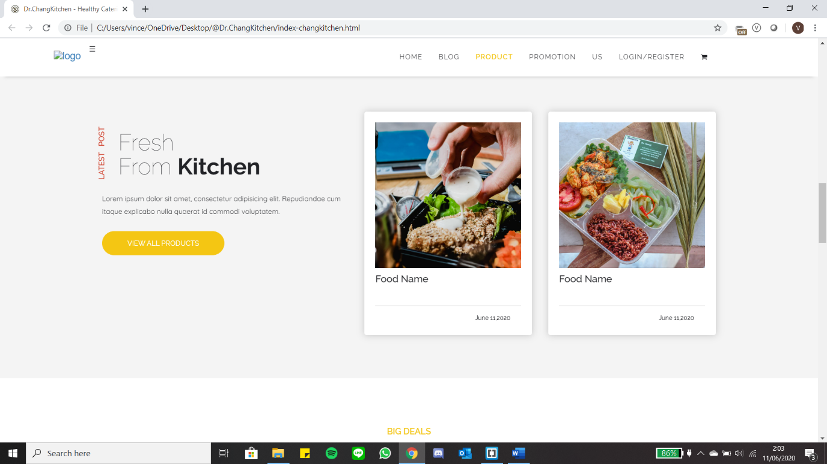

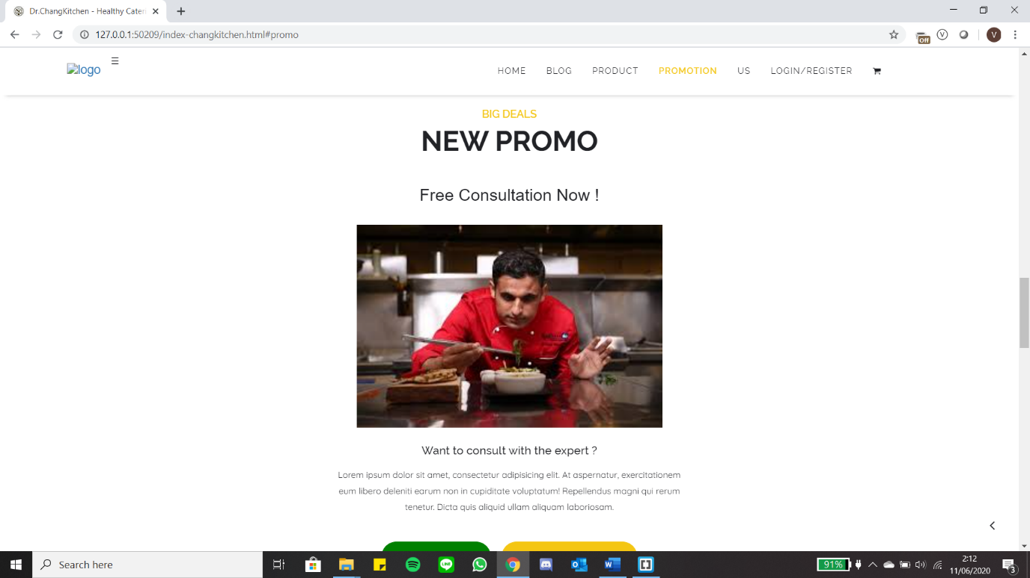

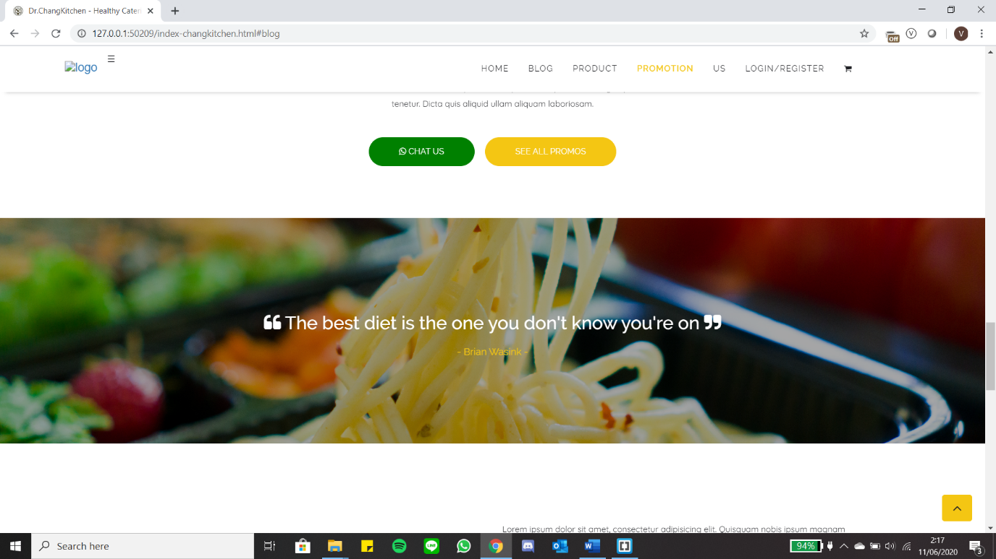

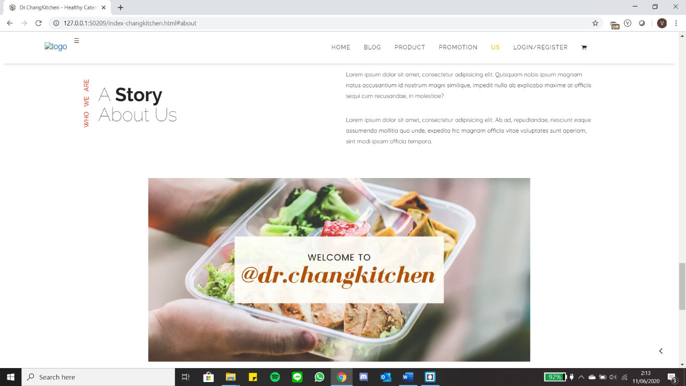

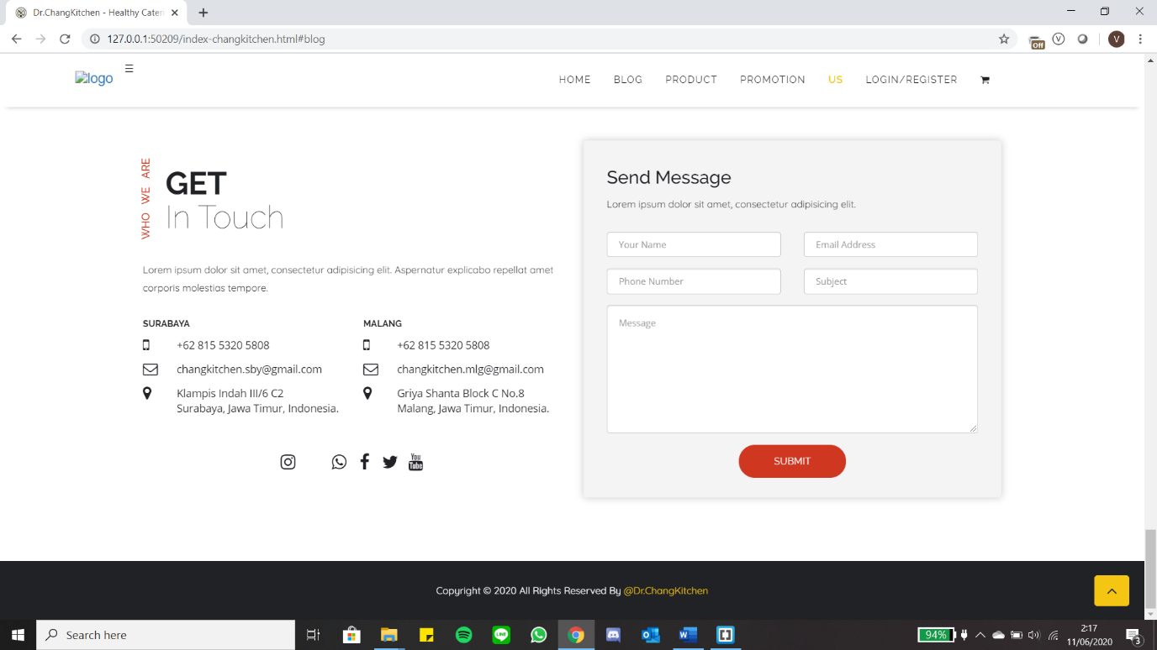

SEE ALL PRODUCTS

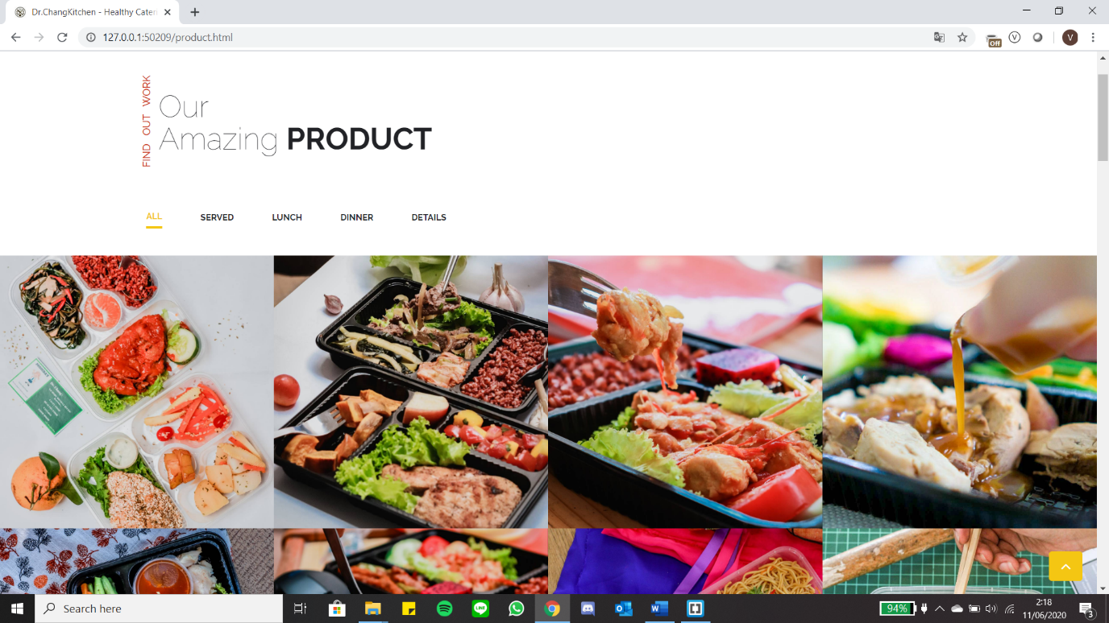

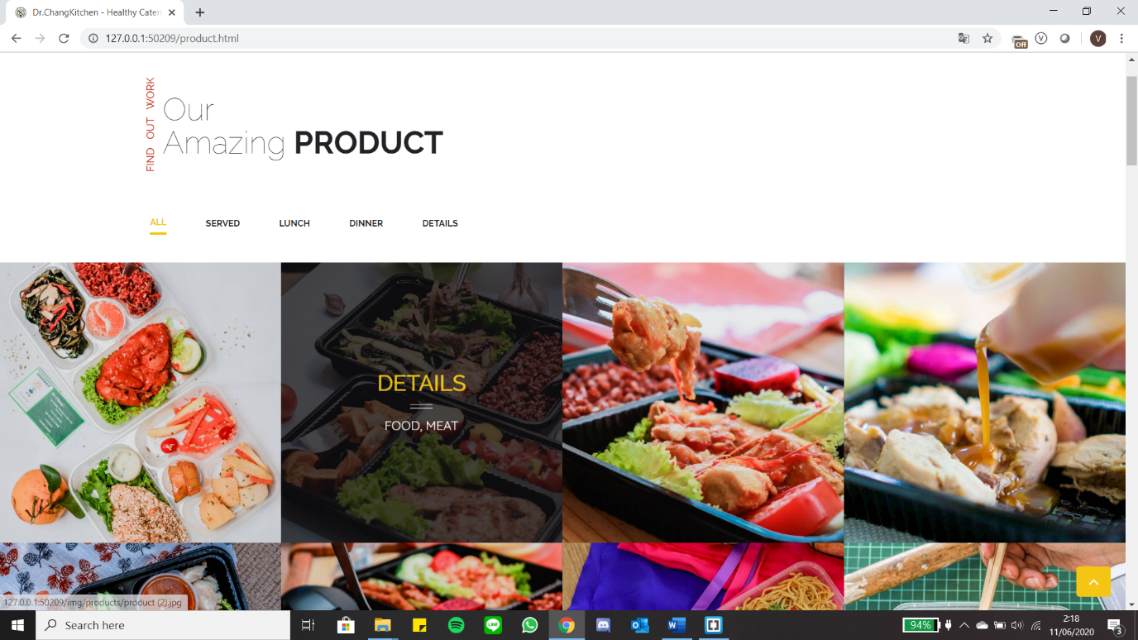

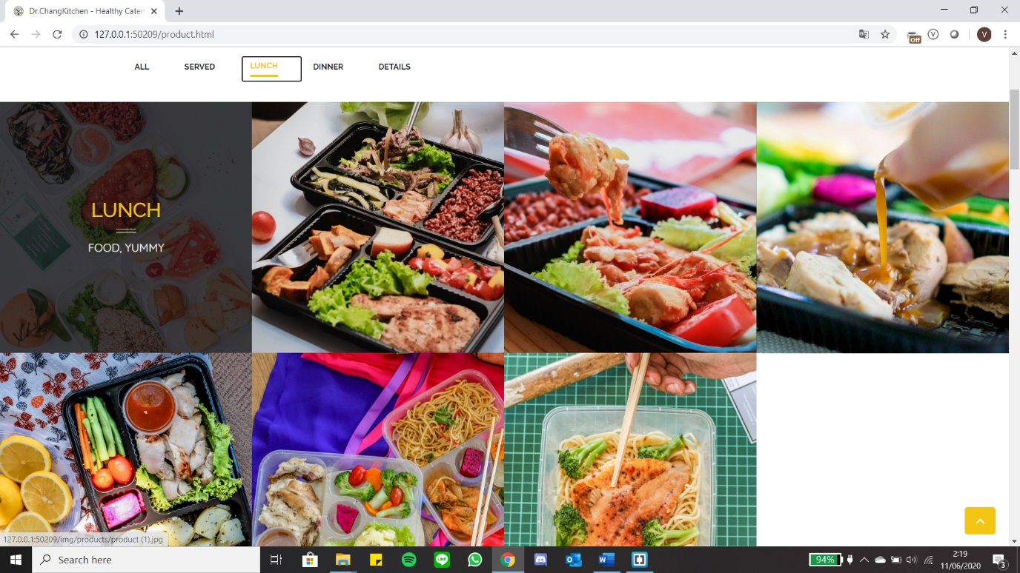

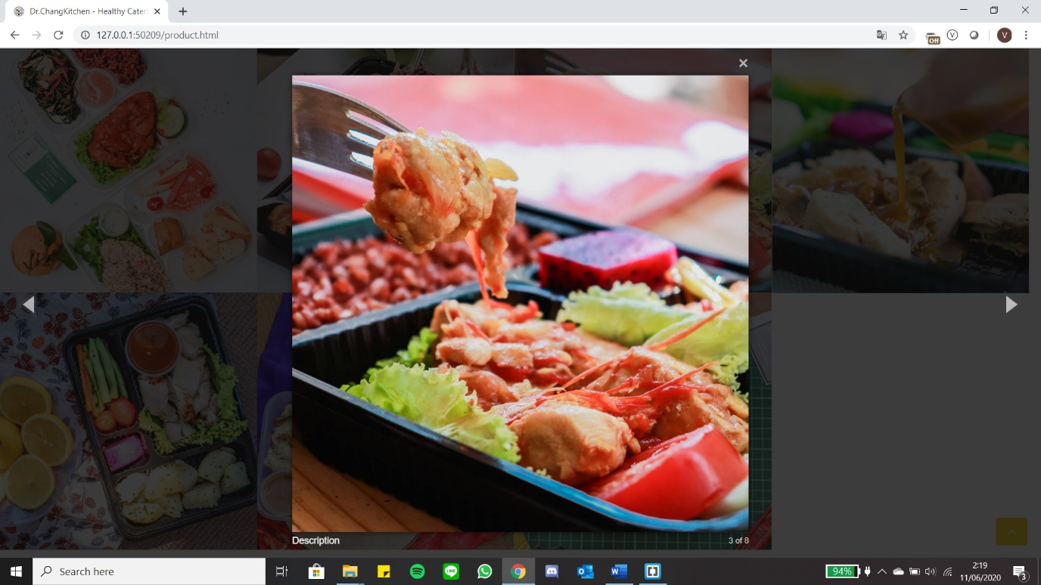

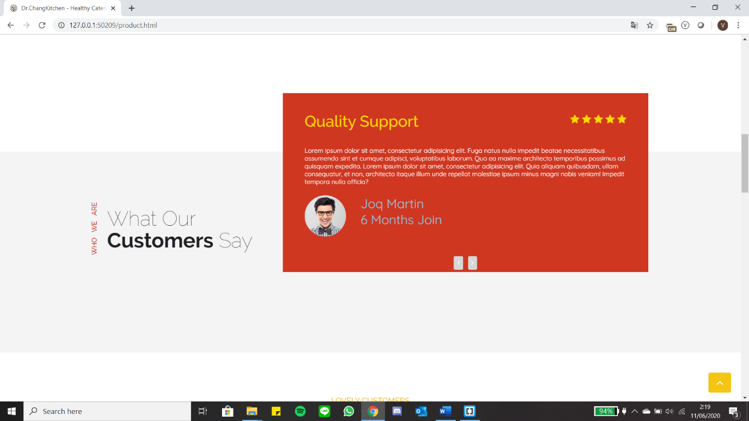

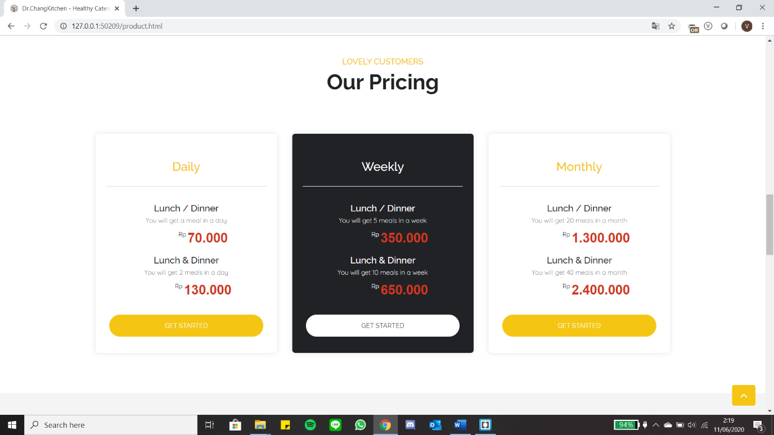

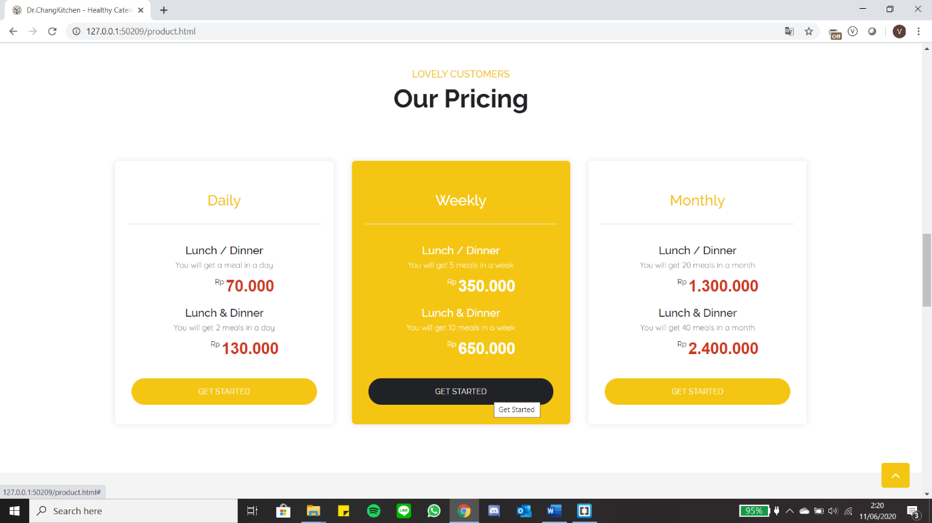

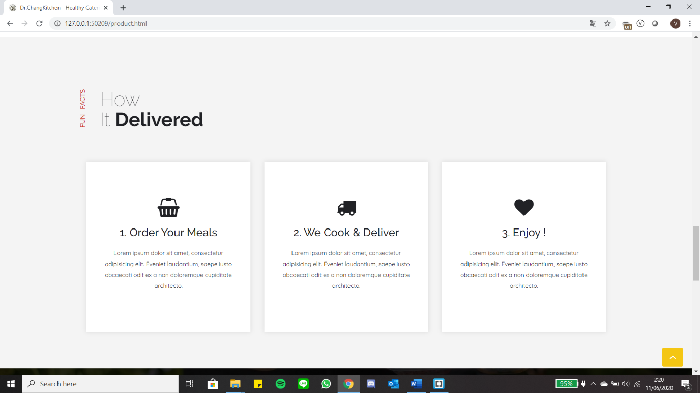

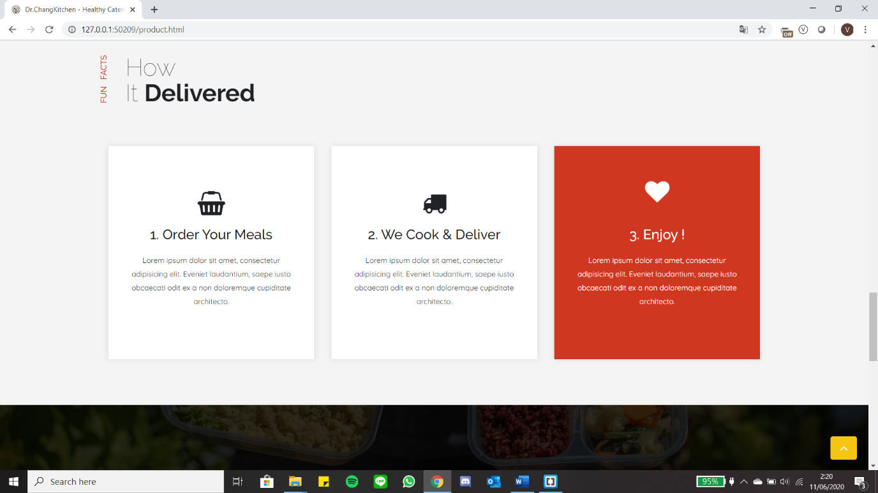

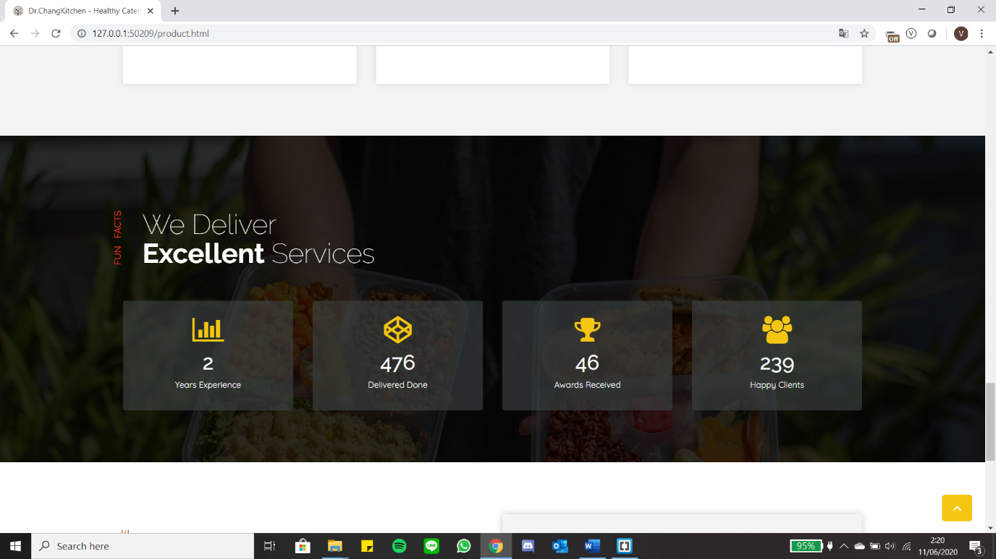

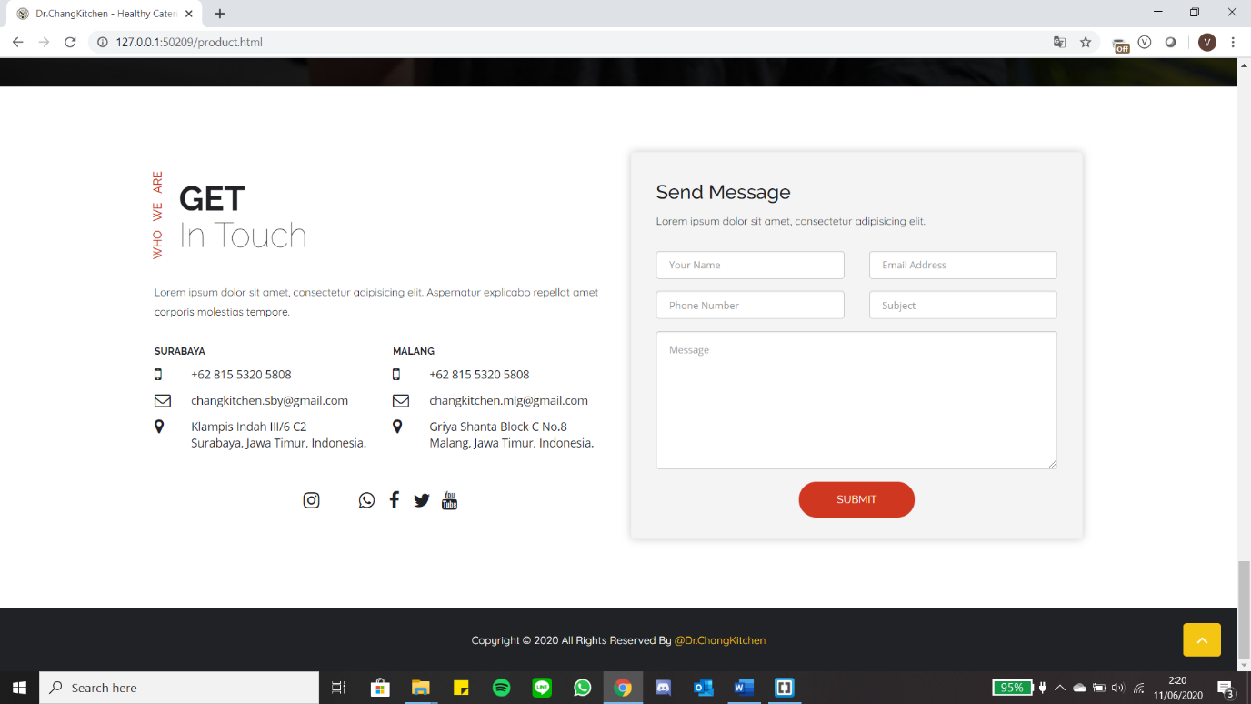

1. **Deployment**

Tahap Deployment ini merupakan tahap terakhir setelah menyelesaikan coding. Pada tahap ini sistem yang dikembangkan diuji apakah penampilan user interfaces dan user experinces sudah berjalan dan muncul sesuai dengan harapan.

|  |  |
| --- | --- |
| **TEST** | **RESULT** |
| Hosting Website | ✔ |
| Homepage | ✔ |
| Product Catalogue | ✔ |

1. **Conclussions and Recommendation**
2. **Conclusions**

Based on the results of the analysis and experiments on this website, the conclusions that can be drawn are as follows:

* Websites regarding catering diets that are made can display complete information about the diet and the amount of nutritional content in food that suits the user's needs. Appearance on this website has also been made responsive so that it can adjust its appearance with the device used by users to access this website.
* This website about catering diets has features that are made according to user needs and can run well when done experiments. Users can see complete information about the diet along with various diet food packages available complete with nutritional content contained and can register or register an account if you want to submit an order. Furthermore, after logging in, the user can choose the food package to be ordered and confirm the order. Admin can provide interesting promo updates available every month and can check user payments and send proof of the success of transactions that have been made by the user.

1. **Suggestion**

As for the suggestions given so that this website can continue to grow and be better, which is as follows:

* In the next update or maintenance, it is hoped that this website can be improved again by fixing some errors that occur when the user takes an action.
* Add a rating feature to the user's favorite food menu (which has already made an order) to encourage other users to make easier decisions about ordering food that has guaranteed taste and quality.
* Working closely with the bank or e-wallet to simplify the process of payment transactions and provide more attractive promos.

1. **Reference**

Ansori. 2020. Pengertian Class Diagram : Fungsi, Simbol, dan Contohnya, (Online), (https://www.ansoriweb.com/2020/03/pengertian-class-diagram.html, accessed 10 June 2020)

Baenanda, Listhari. 2019. Mengenal Lebih Jauh Revolusi Industri 4.0, (Online), (https://bin-us.ac.id/knowledge/2019/05/mengenal-lebih-jauh-revolusi-industri-4-0/, accessed 5 May 2020)

Billah, Ersandi. 2019. Pengertian dan Tahap Metode SDLC Waterfall, (Online), (https://medium.com/@ersandibillah03/sdlc-waterfall-3a3c893be77b, accessed 9 June 2020)

Hestanto, 2019. Model Air Terjun (Waterfall Model), (Online), (https://www.hestan-to.web.id/model-air-terjun-waterfallmodel/#:~:text=Model%20air%20terjun%20(Wate-rfall%20Model)%20adalah%20pendekatan%20klasik%20dalam%20pengembangan,metode%20pengembangan%20linier%20dan%20berurutan., accessed 26 May 2020)

Indowebsite. 2018. Penjelasan dan Arti Website, (Online), (https://www.indowebsite.id/-website/, accessed 5 May 2020)

Kurniawan, David. 2020. Yuk! Mengenal Apa Itu Framework & Fungsinya, (Online), (https://www.niagahoster.co.id/blog/apa-itu-framework/#:~:text=Framework%20adala-h%20sebuah%20kerangka%20program,tersedia%20di%20dalam%20komponen%20framework., accessed 9 June 2020)

Pratama, Aditya Rahmatullah. 2019. Belajar Unified Modeling Language (UML) - Pengenalan, (Online), (https://www.codepolitan.com/unified-modeling-language-uml, accessed 10 June 2020)

Pratama, Aditya Rahmatullah, 2019. Belajar UML - Use Case Diagram, (Online), (https://www.codepolitan.com/mengenal-uml-diagram-use-case#:~:text=Use%20Case-%20Diagram%20adalah%20gambaran,diantaranya%20yang%20memperkenalkan%20suatu%20sistem., accessed 10 June 2020)

Waryanto. 2018. Pengertian Website Lengkap dengan Jenis dan Manfaatnya, (Online), (https://www.niagahoster.co.id/blog/pengertian-website/, accessed 7 June 2020)

Yasin. 2019. Pengertian PHP dan Fungsinya, (Online), (https://www.niagahoster.co.id/blog/pengertian-php/#Apa_Pengertian_PHP_dan_Fung-sinya, accessed 12 May 2020)